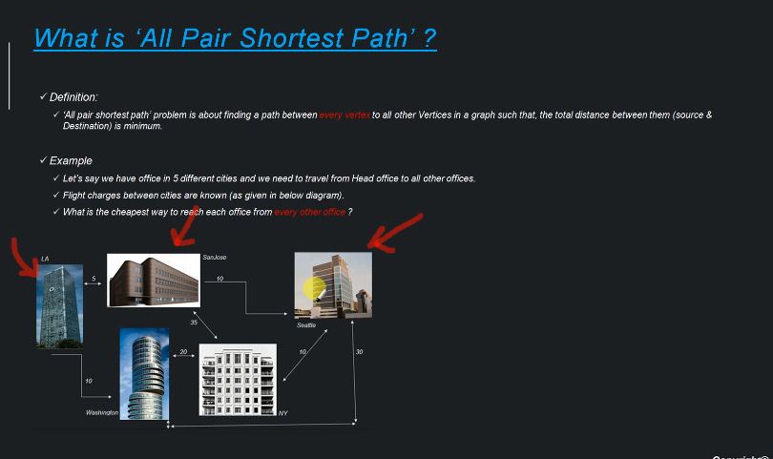

Here we are taking every location and find out the shortest path to every other location.

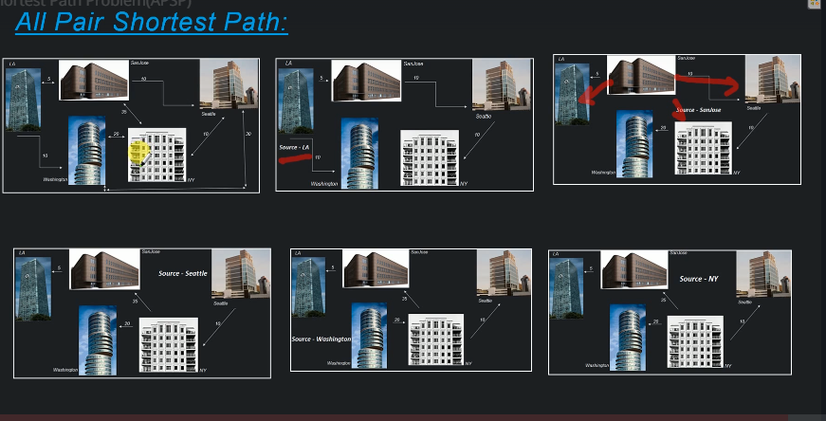

Now here we have to run the same algorithm that we have used multiple times with different source system.

Since there is 5 locations, we will have to run 5 times.

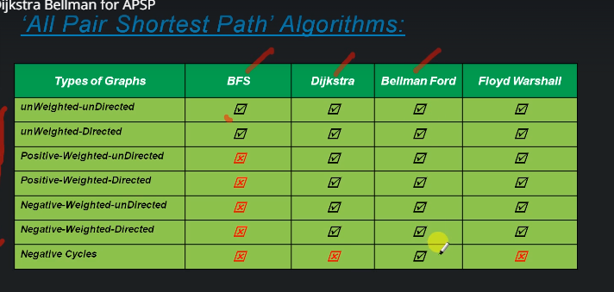

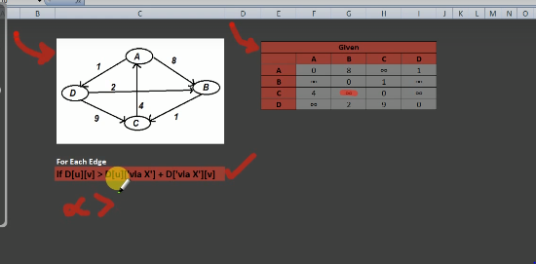

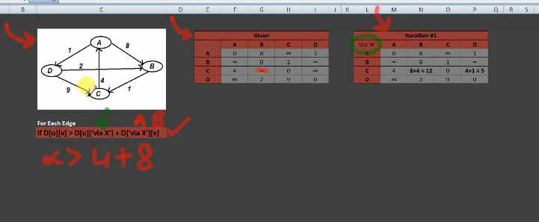

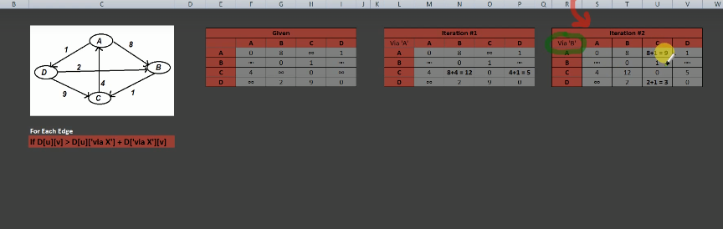

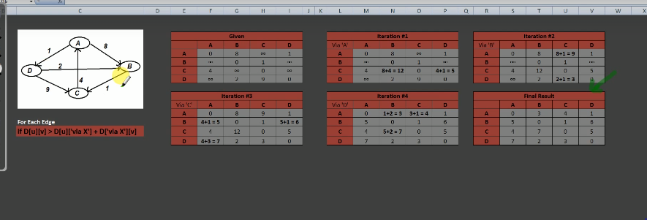

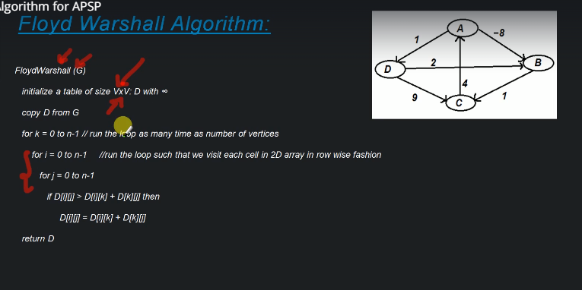

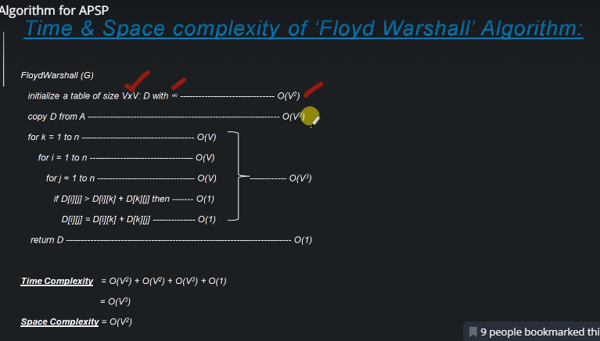

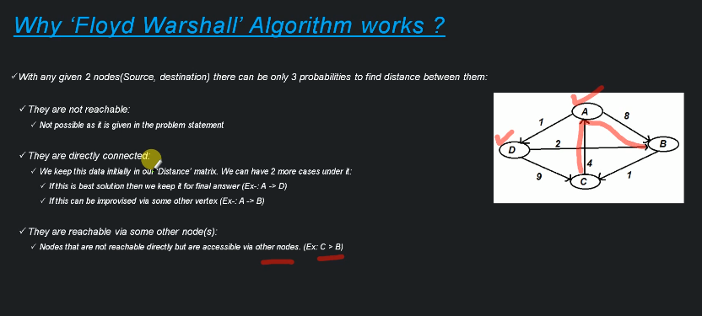

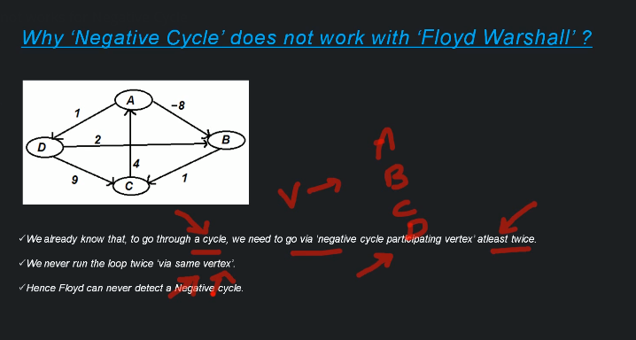

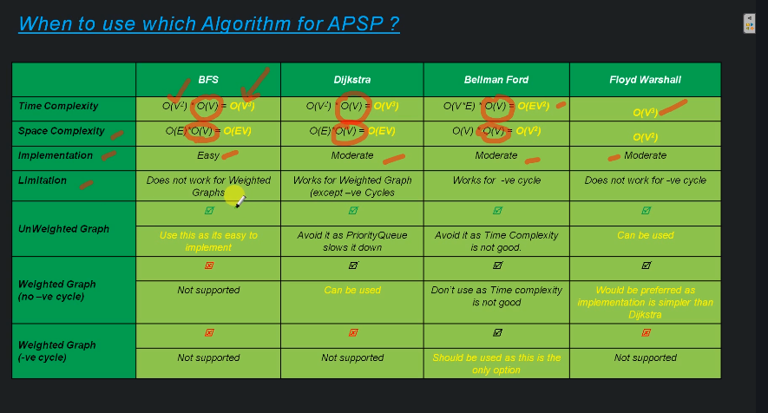

# Python Program for Floyd Warshall Algorithm

# Number of vertices in the graph

V = 4

# Define infinity as the large enough value. This value will be

# used for vertices not connected to each other

INF  = 99999

# Solves all pair shortest path via Floyd Warshall Algorithm

def floydWarshall(graph):

    """ dist[][] will be the output matrix that will finally

        have the shortest distances between every pair of vertices """

    """ initializing the solution matrix same as input graph matrix

    OR we can say that the initial values of shortest distances

    are based on shortest paths considering no

    intermediate vertices """

    dist = map(lambda i : map(lambda j : j , i) , graph)

    """ Add all vertices one by one to the set of intermediate

     vertices.

     ---> Before start of an iteration, we have shortest distances

     between all pairs of vertices such that the shortest

     distances consider only the vertices in the set

    {0, 1, 2, .. k-1} as intermediate vertices.

      ----> After the end of a iteration, vertex no. k is

     added to the set of intermediate vertices and the

    set becomes {0, 1, 2, .. k}

    """

    for k in range(V):

        # pick all vertices as source one by one

        for i in range(V):

            # Pick all vertices as destination for the

            # above picked source

            for j in range(V):

                # If vertex k is on the shortest path from

                # i to j, then update the value of dist[i][j]

                dist[i][j] = min(dist[i][j] ,

                                  dist[i][k]+ dist[k][j]

                                )

    printSolution(dist)

# A utility function to print the solution

def printSolution(dist):

    print "Following matrix shows the shortest distances\

 between every pair of vertices"

    for i in range(V):

        for j in range(V):

            if(dist[i][j] == INF):

                print "%7s" %("INF"),

            else:

                print "%7d\t" %(dist[i][j]),

            if j == V-1:

                print ""

# Driver program to test the above program

# Let us create the following weighted graph

"""

            10

       (0)------->(3)

        |         /|\

      5 |          |

        |          | 1

       \|/         |

       (1)------->(2)

            3           """

graph = [[0,5,INF,10],

             [INF,0,3,INF],

             [INF, INF, 0,   1],

             [INF, INF, INF, 0]

        ]

# Print the solution

floydWarshall(graph);

# This code is contributed by Nikhil Kumar Singh(nickzuck_007)

Following matrix shows the shortest distances between every pair of vertices

0 5 8 9

INF 0 3 4

INF INF 0 1

INF INF INF 0





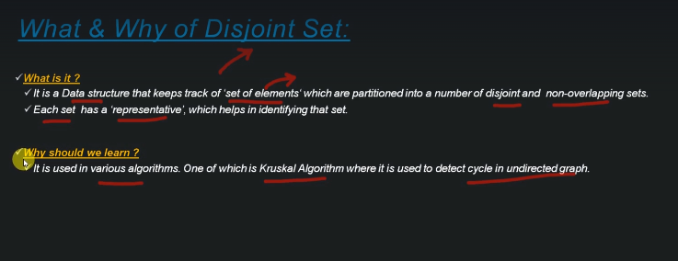

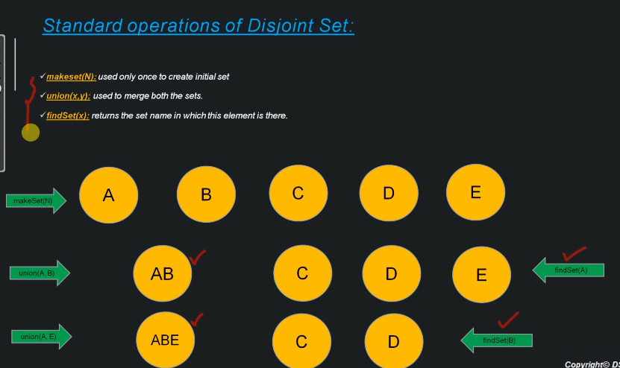

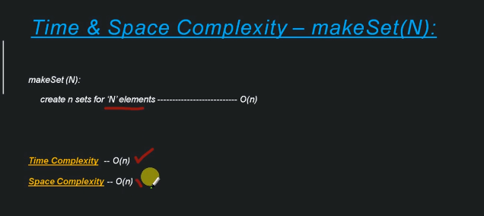

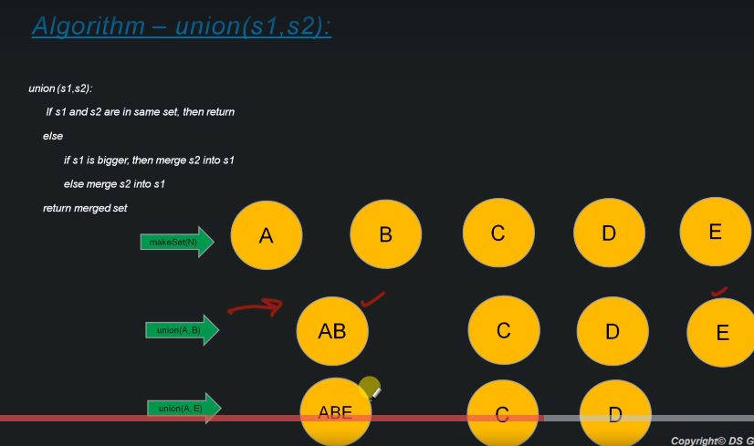

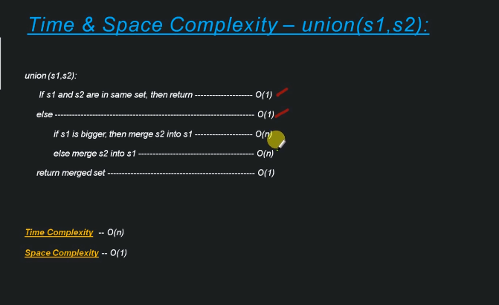

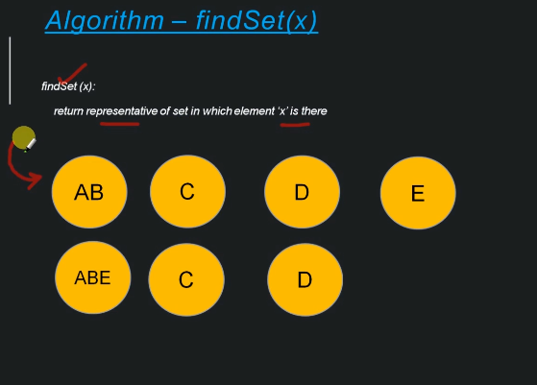



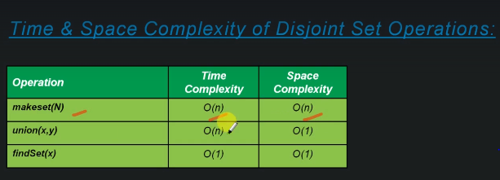



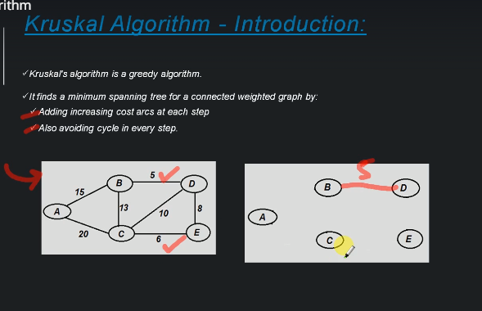

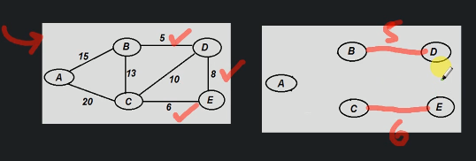

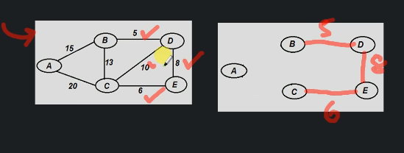

Now we take the next greater weight, 10 it will create a cycle, SO we will not consider it.

